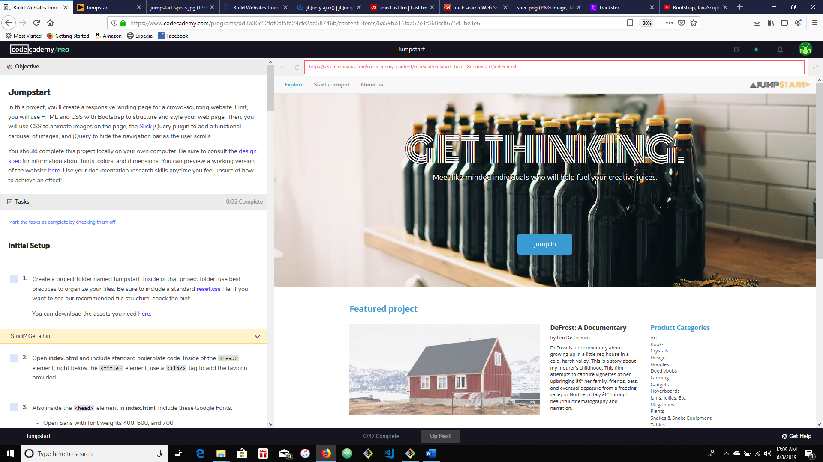

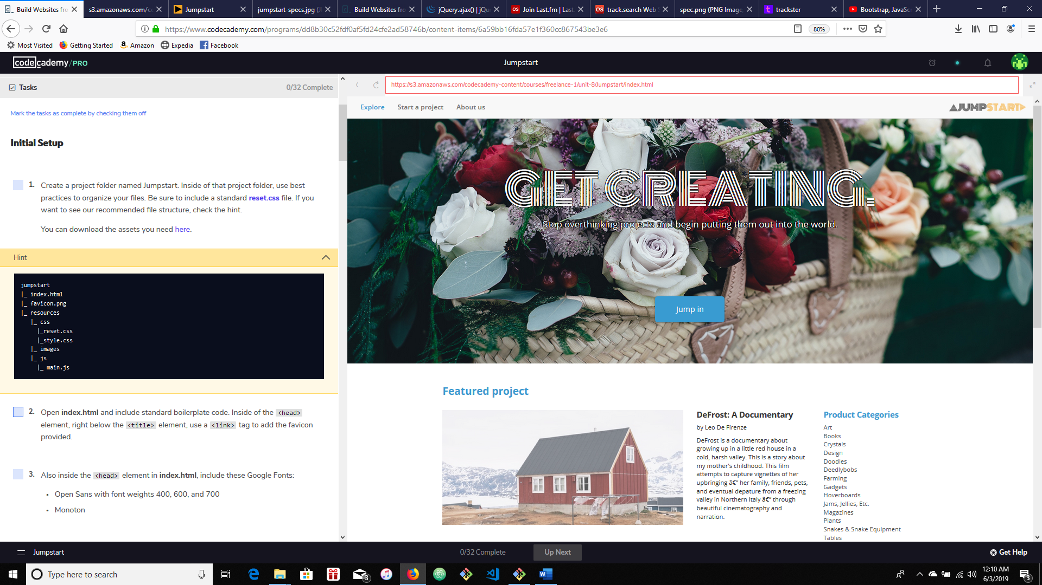

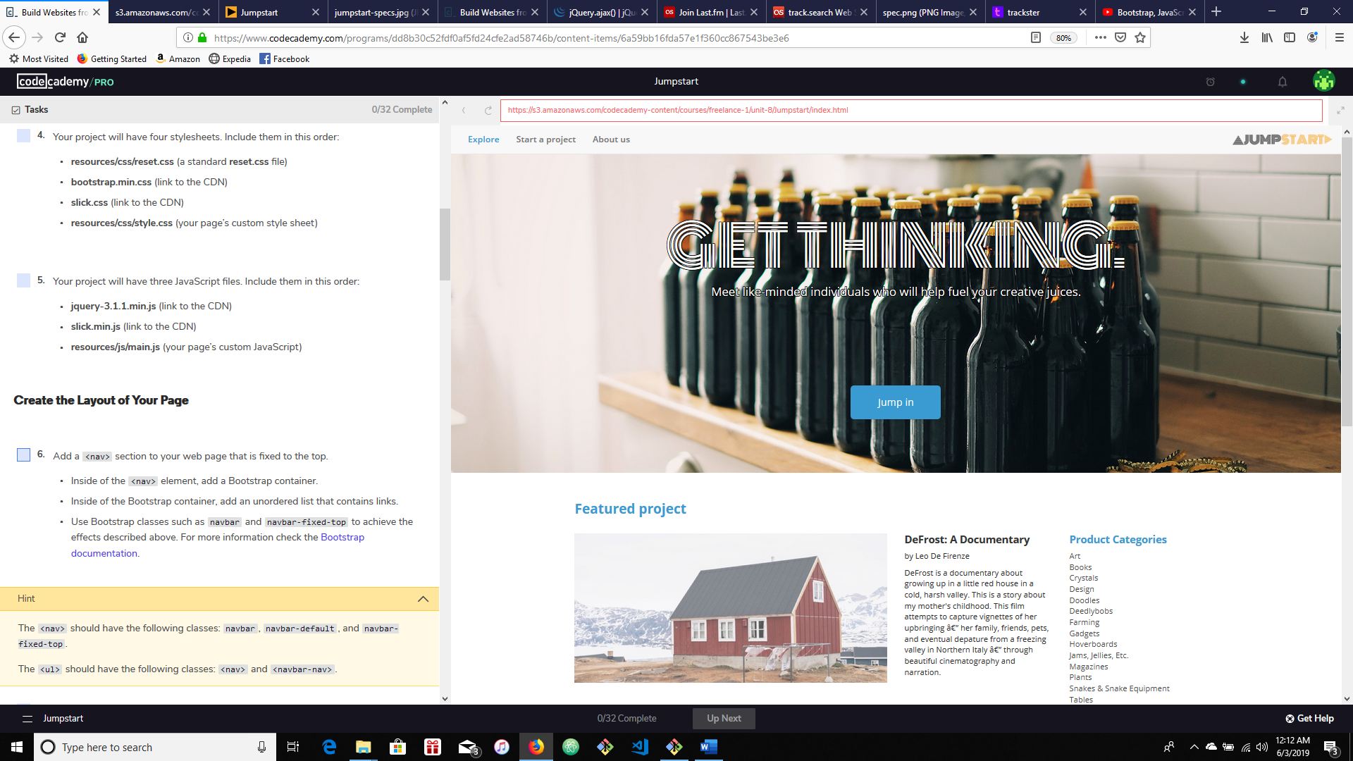

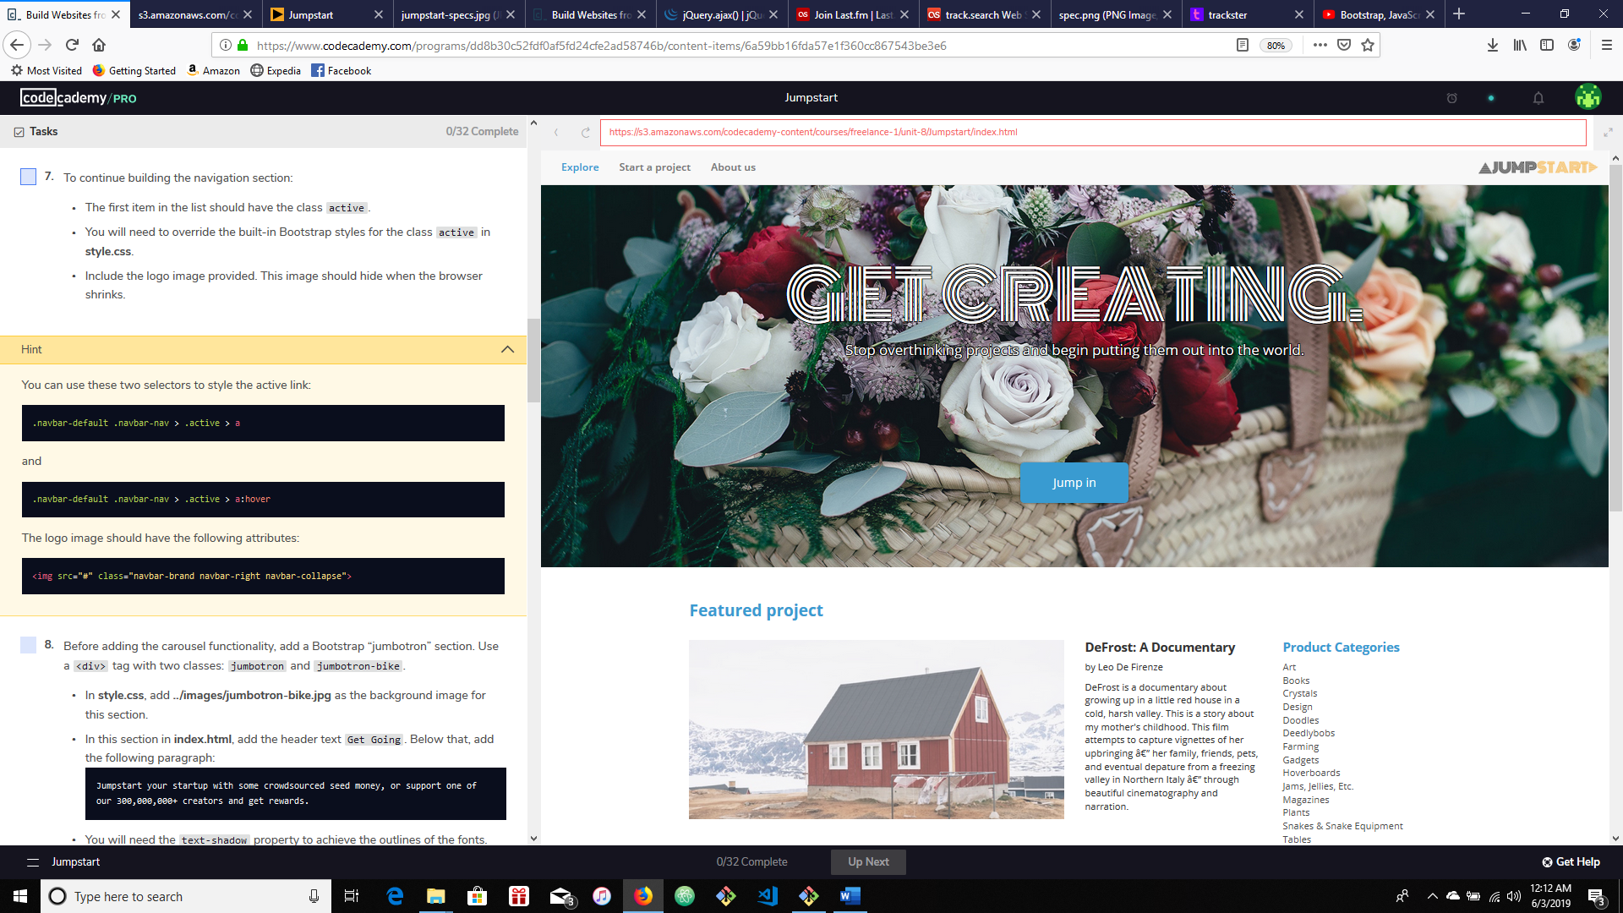

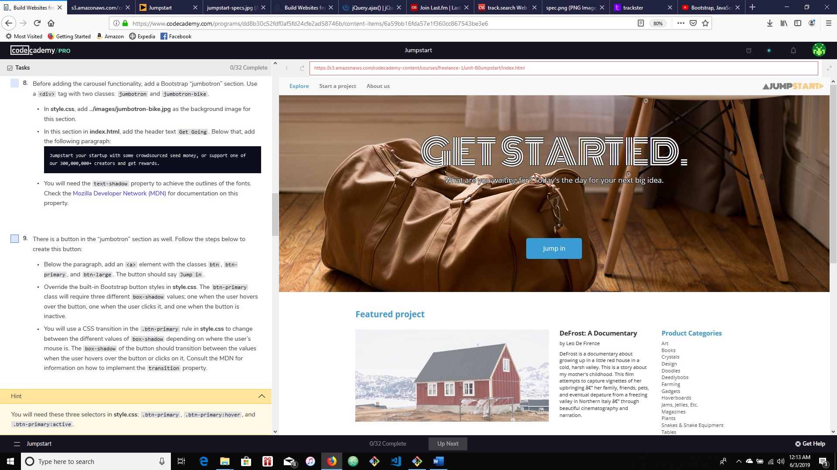

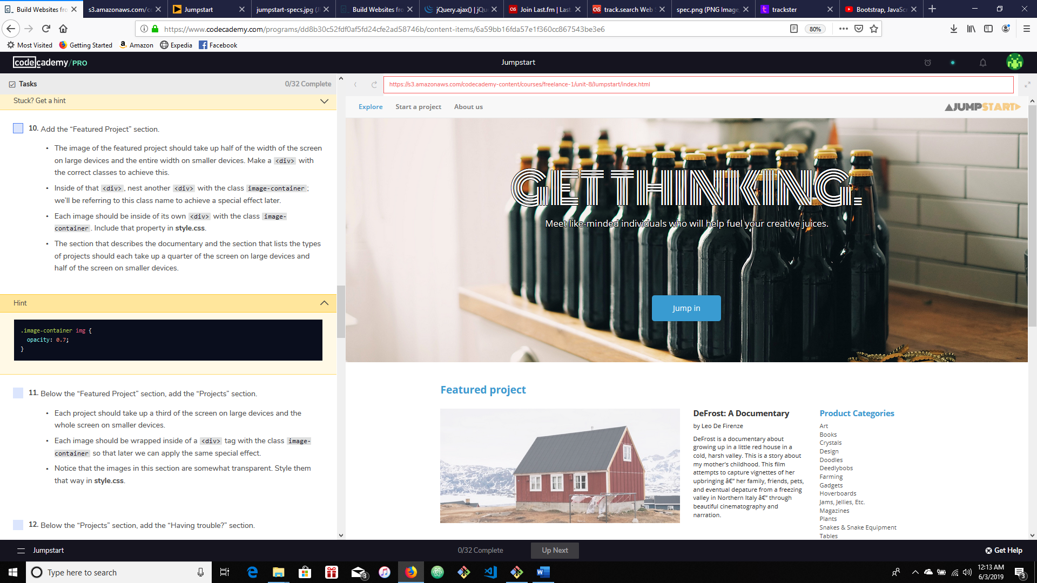

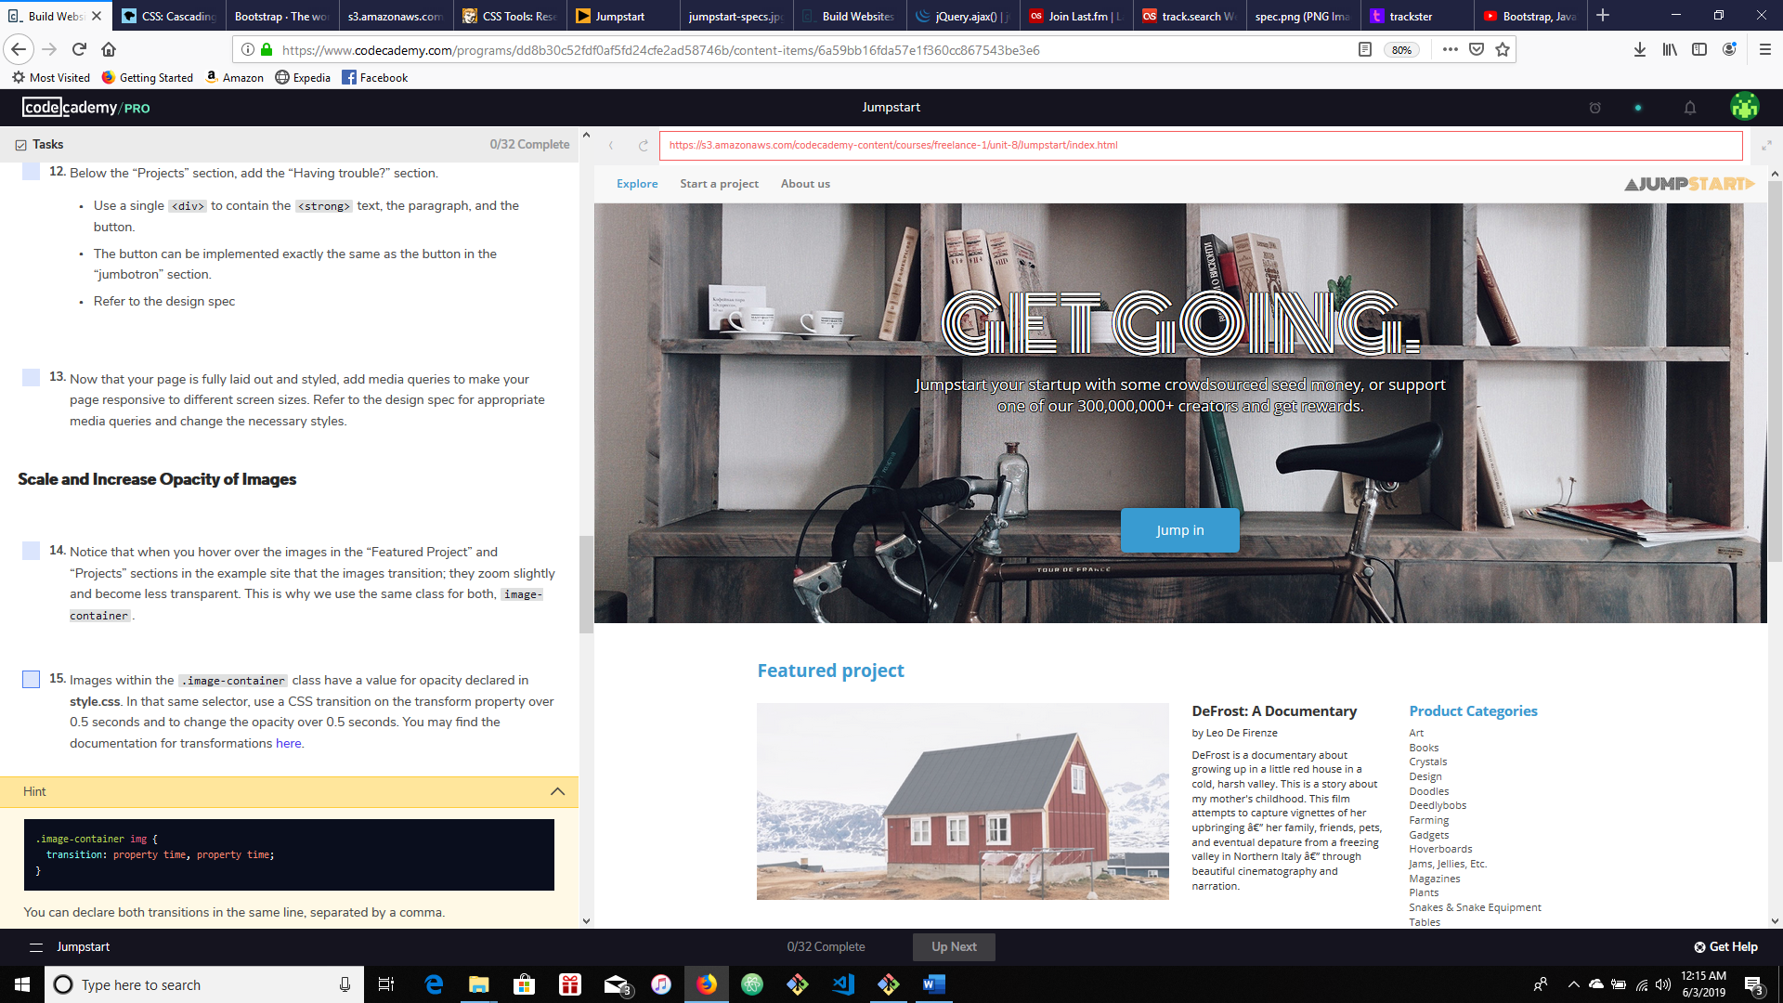

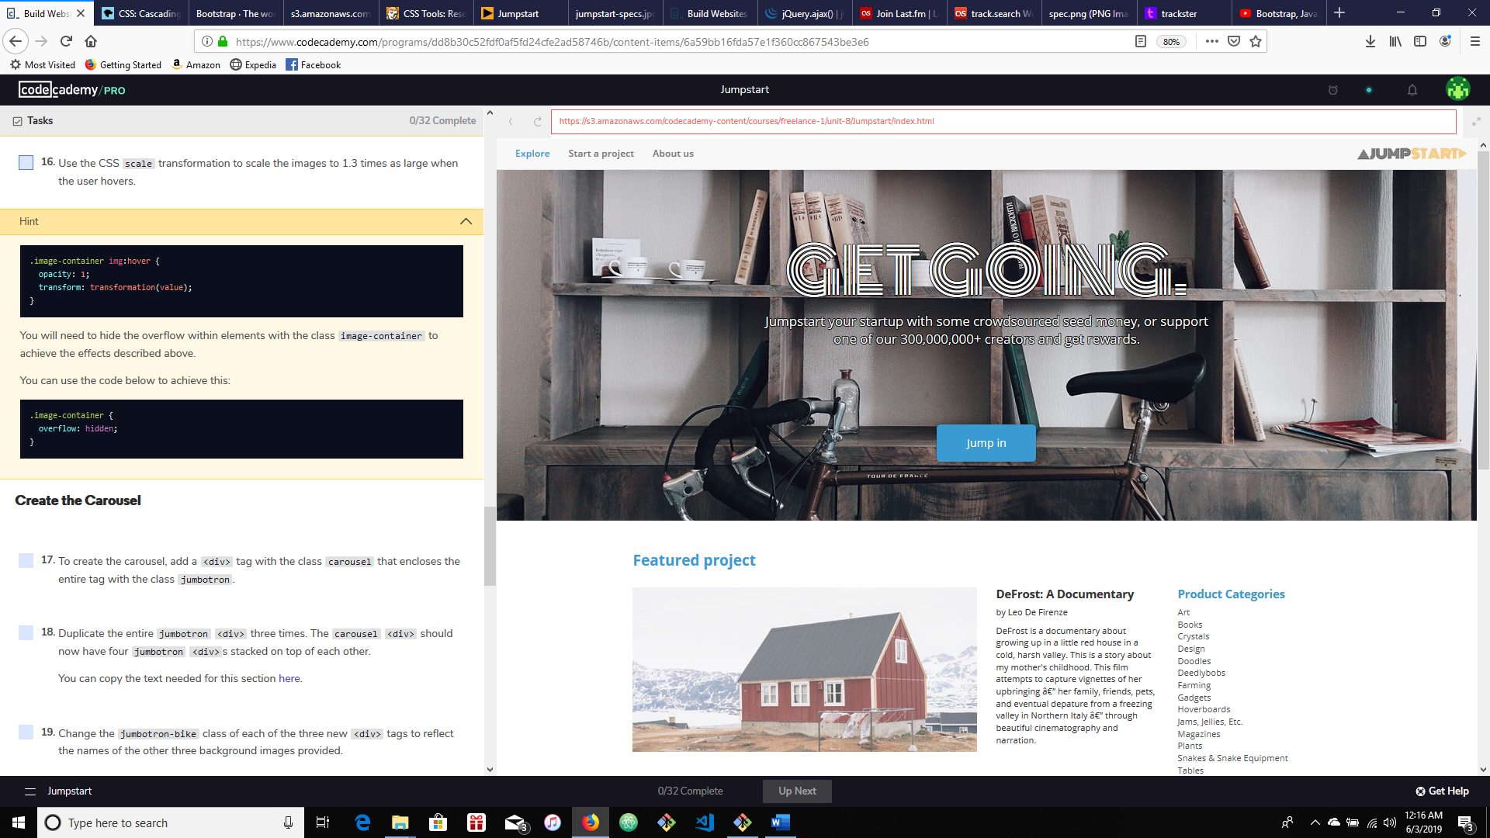

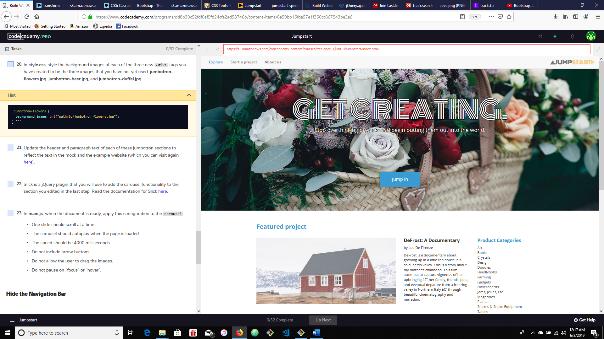

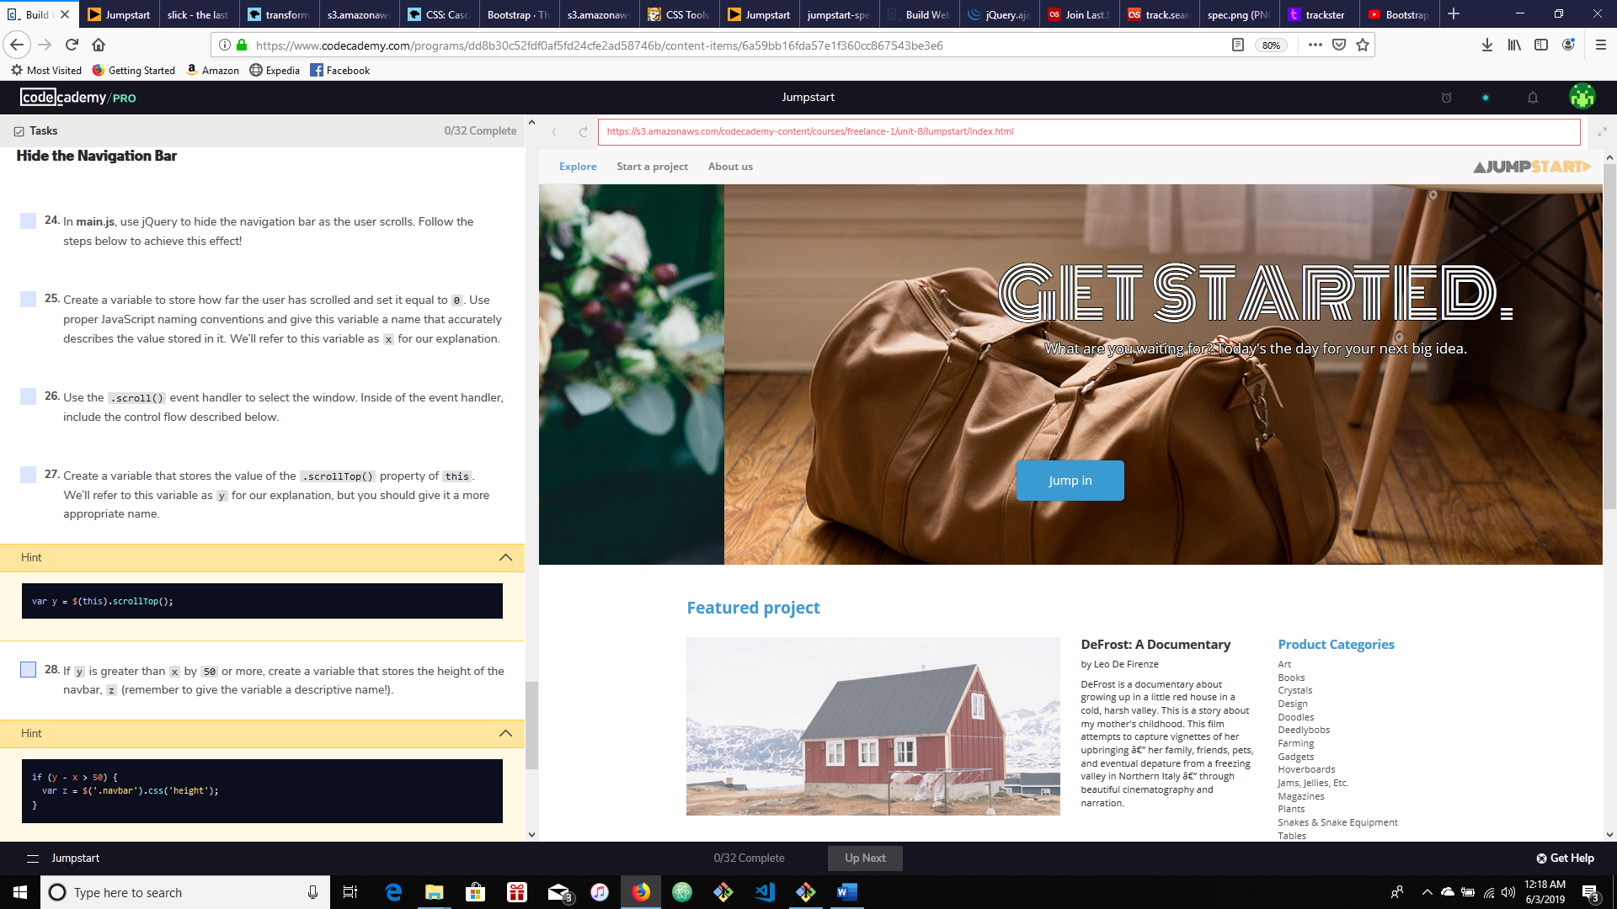

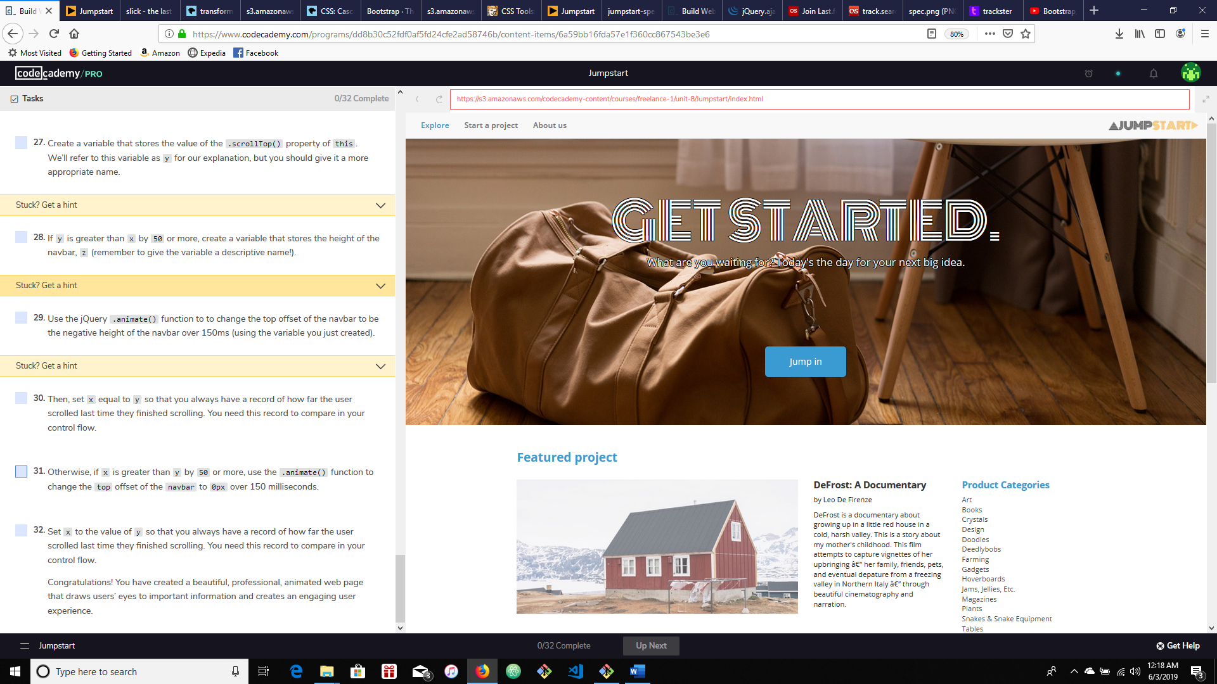

<h1>GET GOING.</h1>

<p>Jumpstart your startup with some crowdsourced seed money, or support one of our 300,000,000+ creators and get rewards.</p>

<h1>GET THINKING.</h1>

<p>Meet like-minded individuals who will help fuel your creative juices.</p>

<h1>GET CREATING.</h1>

<p>Stop overthinking projects and begin putting them out into the world.</p>

<h1>GET STARTED.</h1>

<p>What are you waiting for? Today's the day for your next big idea.</p>